

Dr. Joshua, Harris inc.

2019-10-21

Dr. Harris

7582 Schmidt Highway Apt. 325, Tanyaburgh, CO 93618

Phone: 3778339095

Fax: 9038449290

**Re:** Lauren, Clark

**PHN:** 1483899137

**Birthdate:** 18-Jan-1951

**Address:** 7490 Angela Pines Suite 009, Contrerasport, WA 80960

**Patient number:** 4040717476

To Whom It May Concern:

This is a medical letter to state the above patient is pregnant with expected delivery date of 05-Jun-2025. Hoping this information is satisfactory for your requirements.

Thank you.

Sincerely,

Dr. Joshua, Harris

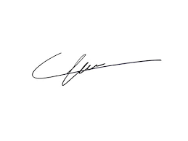

FRCS© NCMP

Clinical Assistant Professor, UBC

Department of Obstetrics and Gynecology SMH